Seoul Youth Center for Cultural Exchange (MIZY)
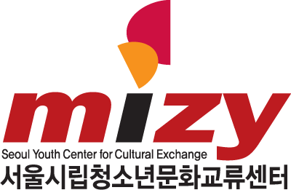
World Heritage Class Trip Program, Fall Semester 2020

Instructor Application Form
First Name |  | Last Name
Nationality |  | Sex (F/M)
E-mail
Phone Number
(Mobile)
Affiliation | ※ Type in your school or company name
Educational Background | ※ e.g. major & year, undergraduate, graduate, MA, PhD, etc.
Self-introduction and  Related Experience | ※ Please write in English
Motivation to apply | ※ Please write in English or Korean
English ability
Other language ability
* Are you able to attend the program orientation & workshop (9.11)?

CONSENT FORM FOR PROCESSING THE PERSONAL INFORMATION

To comply with the Article 15, Article 17, and Article 24 of「Personal Information Protection Act」, Seoul Youth Center for Cultural Exchange(MIZY Center) must have your consent about processing (collection, use, transfer, etc.) your personal information as below.

■ Consent to the Collection of the Personal Information
Purposes of Collection | Reviewing qualification, supporting after selection, following-up management, paying and reporting income tax according to deducting withholding tax from tuition fee, etc.
Collected Items | All information filled in submitted documents including name, mailing address, phone number, email address, and banking information
Period of Retention and Use | Until the purposes of collection and use of personal information are attained from the day of agreement
Company of Collection and Use / Program Name | Seoul Youth Center for Cultural Exchange(MIZY) / 2020 “Deep-rooted World Heritage” Program
※ You have the right to refuse the collection and use of your personal information as above. However, if you refuse the collection and use of your personal information, your payment could be cancelled.
I hereby agree with the collection of the Personal Information.
□ I Agree □ I Do Not Agree
■ Consent to the Use of Personally Identifiable Information
Purposes of Use | Reviewing qualification, supporting after selection, following-up management, paying and reporting income tax according to deducting withholding tax from tuition fee, etc.
Collected Items | All information filled in submitted documents including name, mailing address, phone number, email address, and banking information
Period of Retention and Use | Until the purposes of collection and use of personal information are attained from the day of agreement
Company of Collection and Use / Program Name | Seoul Youth Center for Cultural Exchange(MIZY) / 2020 “Deep-rooted World Heritage” Program
※ You have the right to refuse the collection and use of your personal information as above. However, if you refuse the collection and use of your personal information, your payment could be cancelled.
I hereby agree with the use of the Personal Information.
□ I Agree □ I Do Not Agree

■ Consent to the Processing of Personally Identifiable Information
To comply with the article 24 of「Personal Information Protection Act」, Seoul Youth Center for Cultural Exchange(MIZY Center) must have your consent about processing (collection, use, transfer, etc.) the personal information (identification number, alien registration number, passport number). I hereby have carefully read and sufficiently understood the explanation on「Processing Personal Information and Personal Identifiable Information」and agree with the information in this sheet.
※ You have the right to refuse the collection and use of your personal information as above. However, if you refuse the collection and use of your personal information, your payment could be cancelled.

I hereby agree with the collection and use of the personally identifiable Information.
□ I Agree □ I Do Not Agree

2020 . . .

Recipient Name : (signature)
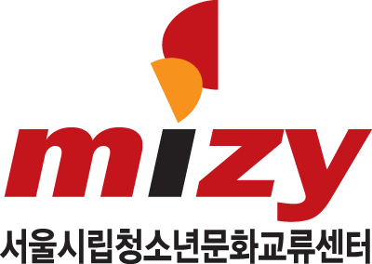 Seoul Youth Center for Cultural Exchange

